**Zero Waste Street Food Event No.4 – 1st June 2024**

Another good event, although due to the mix of traders, fewer plates and bowls were handed out. Many were supportive though, and it was useful to get there earlier (4 pm would be ideal) to have more time to discuss. A bigger push on forks this time – we aimed to give each trader a supply, as it’s an easy switch. **Volunteer numbers still low**, but lots of people were away.

**Set-up**

* 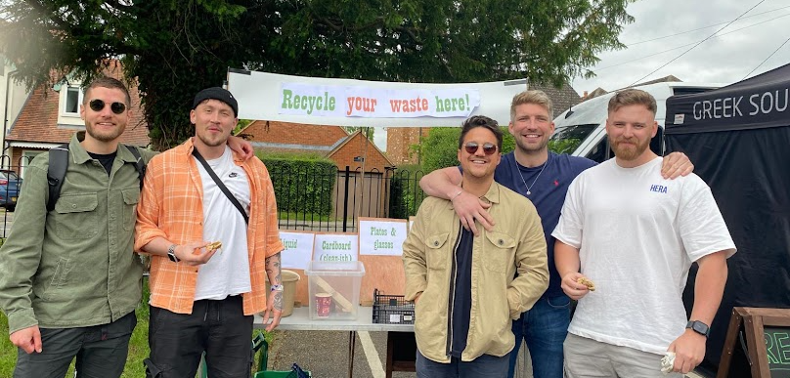Zero waste hub at kitchen hatch with bunting and signboard
* Recycling station outside (all outside bins removed)
* Recycling station inside opposite the kitchen hatch (no other bins inside)
* 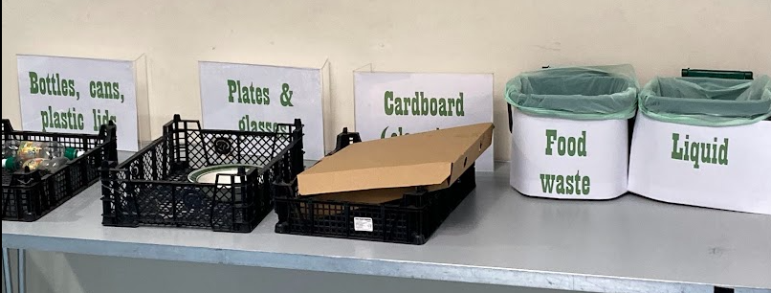Bar fully switched to reusable glasses

*Top, happy recyclers, bottom, indoor recycling station showing printed labels*

**Results**

* Plates: **22** (down from 58 last time) washed
* Bowls: **26** (up from 40 last time) washed
* Cardboard containers: **105** sent for recycling **(up from 60 last time), 90** non-recyclable collected **(down from 112 last time)**
* Food waste: c. **6kg collected** (same as last time)
* Forks: **118 washed** (slightly down)
* Glasses: at least **200** disposable glasses avoided

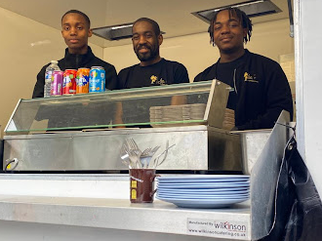**Analysis**

Still losing glasses – we could think about a deposit, but that could be fiddly. If we restock with remaining budget, we could get sturdier, less disposable-looking ones, ideally printed with ‘re-use me).

The Greek souvlaki stall said that maybe they could have done more if we had discussed in advance. The problem is that Alex sends out an email a few days before, and I’m not convinced many of the traders read it.