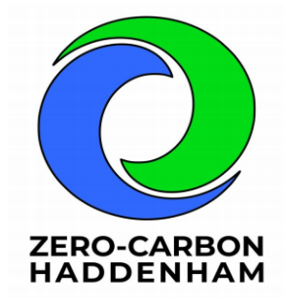**Zero Waste Street Food Event No.3 – 4th May 2024**

A further refinement of the system, and the most successful yet – waste sorting outside as well as inside, more reusables used and more recycling/food waste collected.

* Printed signs in Perspex stands for individual traders and the bar were useful
* Printed signs for the different waste categories also looked good
* Definitely need a designated photographer
* We could have done with more than 3 volunteers on the team
* Need to be ready to talk to traders from 4.15, as they are too busy from 5

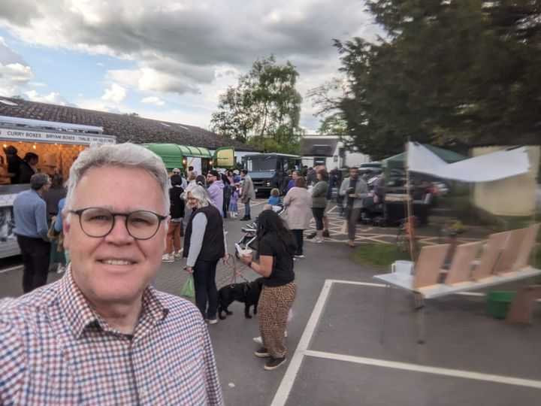**Set-up**

* Zero waste hub at kitchen hatch with bunting and signboard
* Recycling station outside, opposite Bokkie (most of the outside bins removed)
* Recycling station inside opposite the kitchen hatch (no other bins inside)
* Bar fully switched to reusable glasses

Photo: outdoor recycling station from the rear (no other pics available!)

**Results (more accurate figures this time with more categories recorded)**

* Glasses: at least **200** disposable glasses avoided
* Plates: **58** (up from 32 last time) washed
* Bowls: **40** (up from 28 last time) washed
* Recycling - hard to measure but needed to jump in the bin to fit it all in!
* Cardboard containers: **60 sent for recycling, 112 non-recyclable collected**
* Food waste: c. **6kg collected** (4kg last time)
* Forks: **135 washed**

**Analysis**

* Bowls remained popular with Bokkie, but no noodle stall this time.
* OMG (burgers etc) very happy to use plates, and got through a lot. Donut stall also happy to take plates but didn’t give out many
* This time we gave stalls forks at the start – an easy swap, and easier to do now we’ve found the extra village hall fork stash!
* People still like to be able to collect plates from the hatch, but no-one takes them to queue up at stalls – we need to focus on getting the traders to take a stack
* Need to monitor stalls closely to make sure they don’t run out of plates/bowls
* Also need to monitor the two waste stations closely
* Still losing glasses despite removal of more bins (talk to Alex about potential deposit next time)

**Also worth noting that this initiative has sparked conversations with the Beer Festival committee about improving their recycling, and we also brought food waste bins to Haddenham Gates.**