**Zero Waste Street Food Event 2 – 6th April 2024**

Our second time around so we knew more what we were doing. A really positive event, with more support from the traders and better collection rates – well done team!

**Set-up**

* 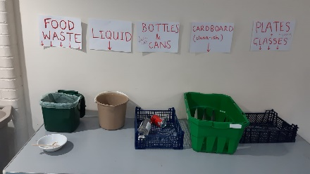Zero waste hub at kitchen hatch with bunting and signboard
* Sign board outside front door next to sign for the bar
* 2 recycling stations, one in the foyer, one in the main hall (no other bins inside)
* Bar fully switched to reusable glasses

**Results (approximate figures – need to improve recording!)**

* Glasses: around **200** disposable glasses avoided
* Reusable crockery: **32 plates** washed, **28 bowls**
* Cardboard containers: **76 sent for recycling**
* Food waste: c. **4kg collected** (double last time)

**Analysis**

* 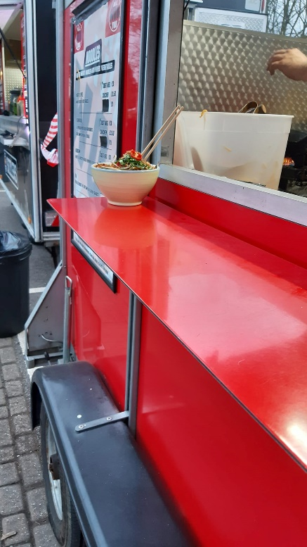Bowls were a big hit with the traders (particularly the noodle stall and Bokkie) – can we source more? Alan to ask Paddy, also for knives and forks (see below).
* We should forget about the idea of getting people to collect plates before queuing up and focus on providing them to traders. Ideally offering a selection of different formats.
* Recycling hub could be further improved to be even clearer and discourage more from ending up in general waste.
* One trader asked for clearer explanation of the scheme at the beginning, and suggested we could make up A4 posters explaining the aims and how it works to go in a Perspex display. These could be displayed by the individual traders.
* Lots of disposable forks still used (we collected around 75 but many more went in the bin), but we don’t have a big enough stock to offer some to each stall – need to source more.
* I had not factored in loss of glasses (we lost 7 half pint pots and 5 pint glasses). Better control of general waste should improve this.

**For next time**

* Tackle the outside waste situation (it may well be warmer, with more people eating outside)
* Will need to think of signage to make us really visible (possibly illuminated – does anyone have a string of LEDs that would make something like this?
* Work on disposable cutlery
* **More photos!** Including team photo – need a designated photographer?